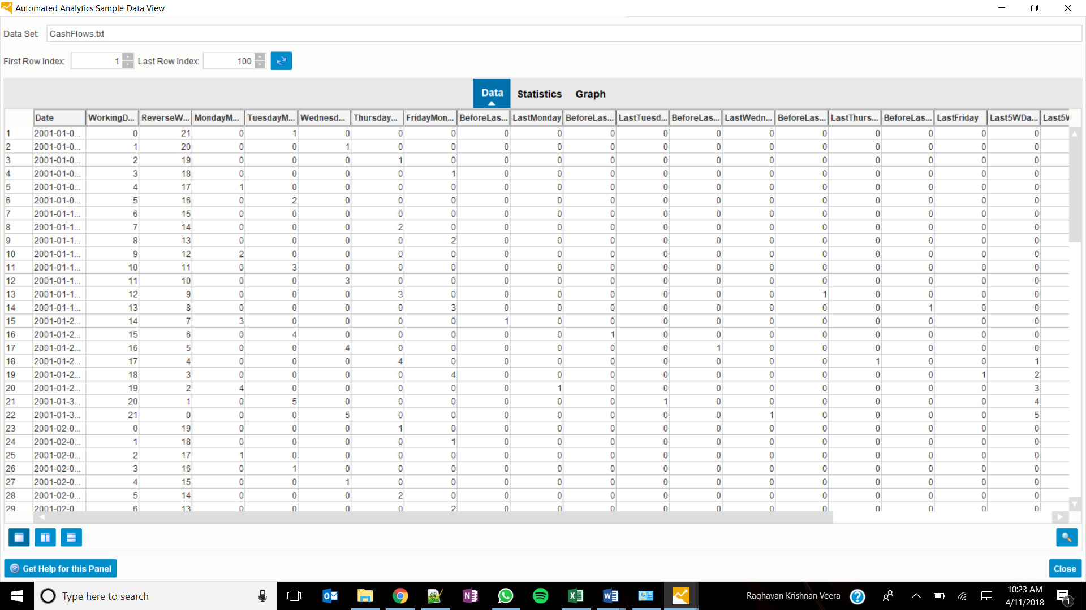

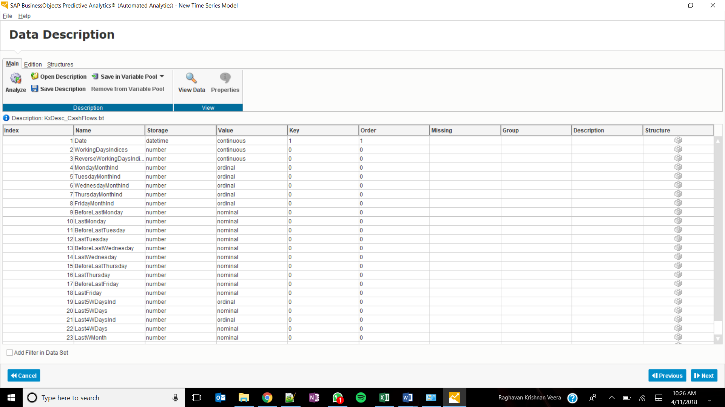

Summary:

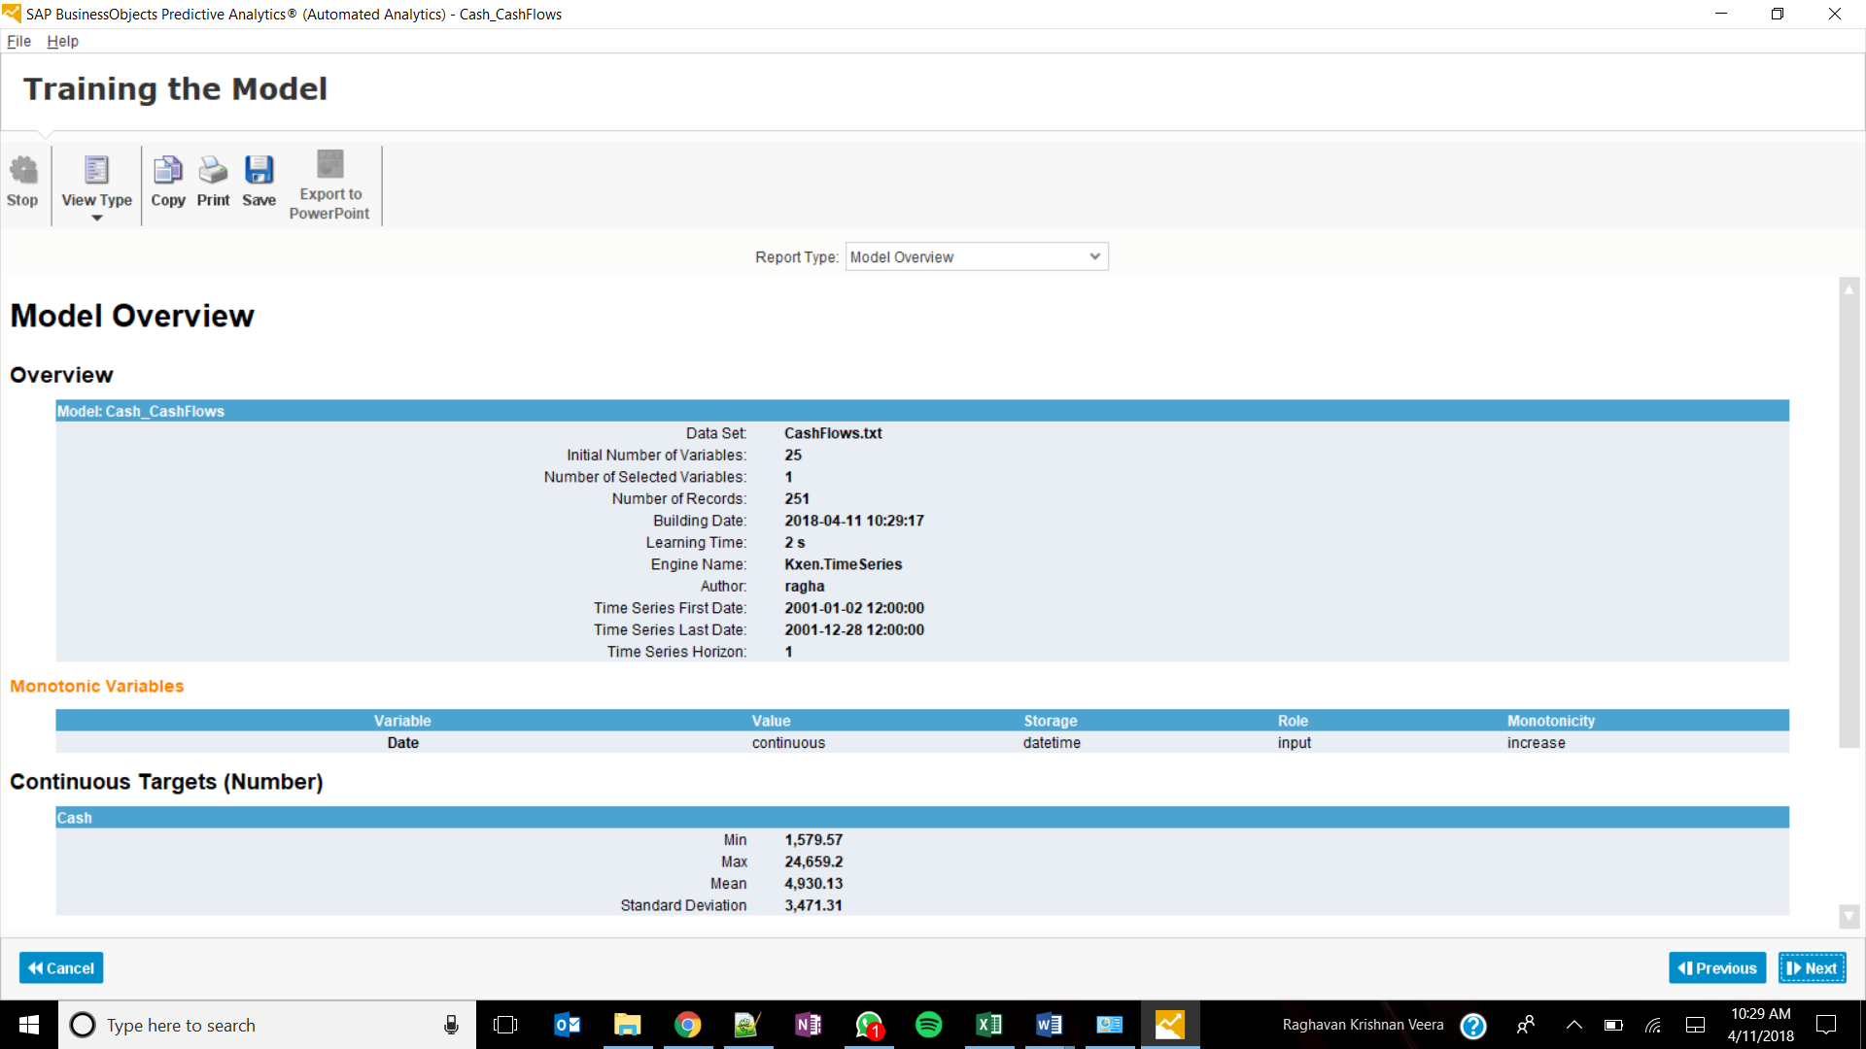

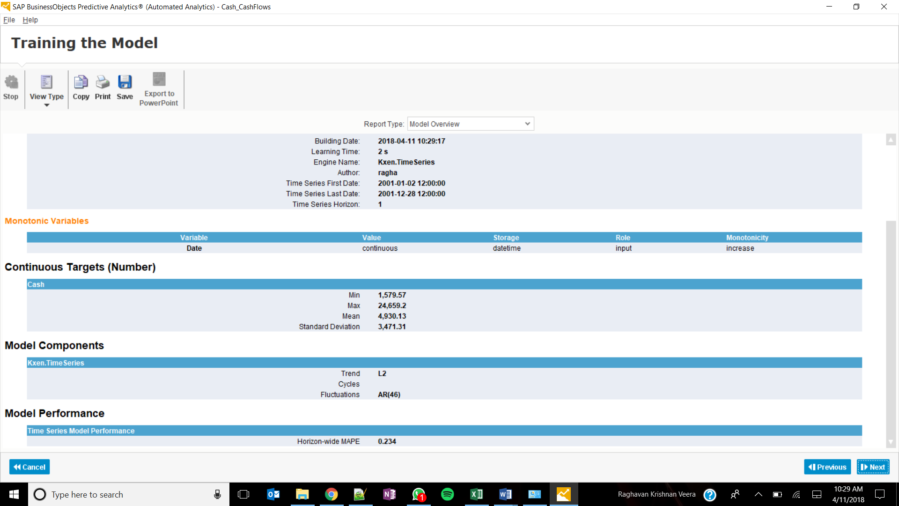

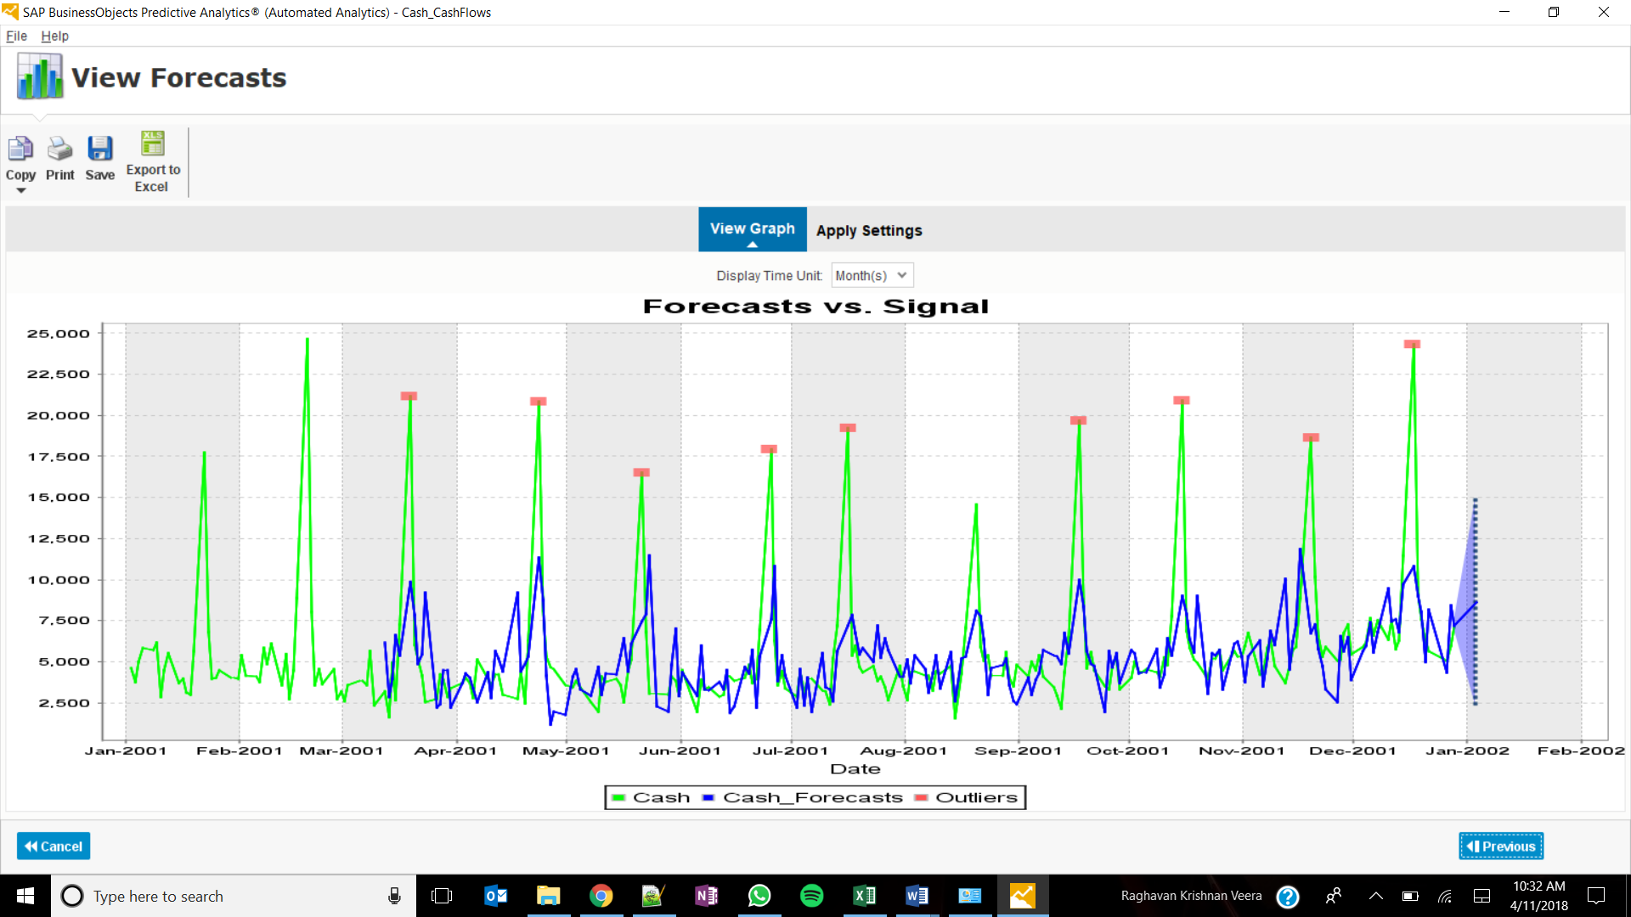

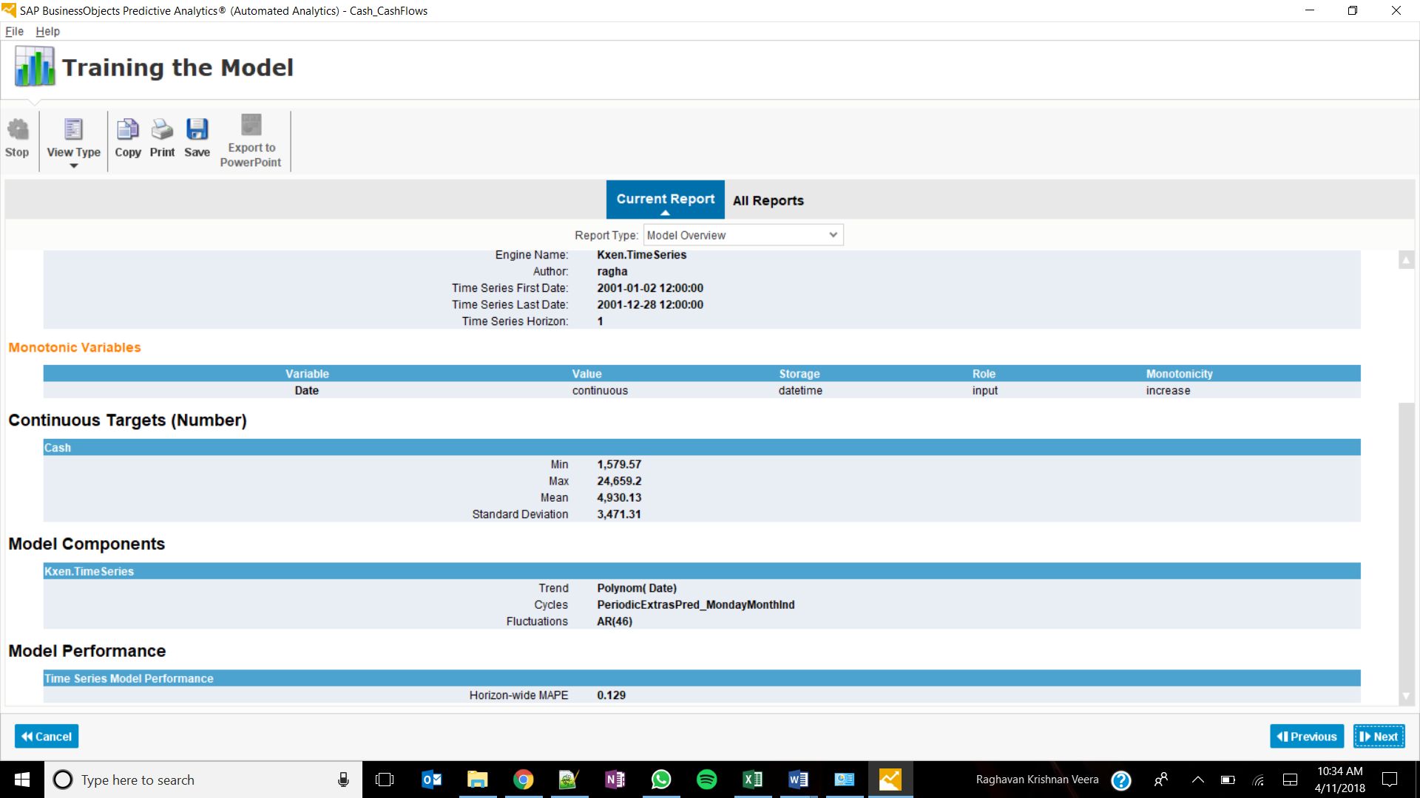

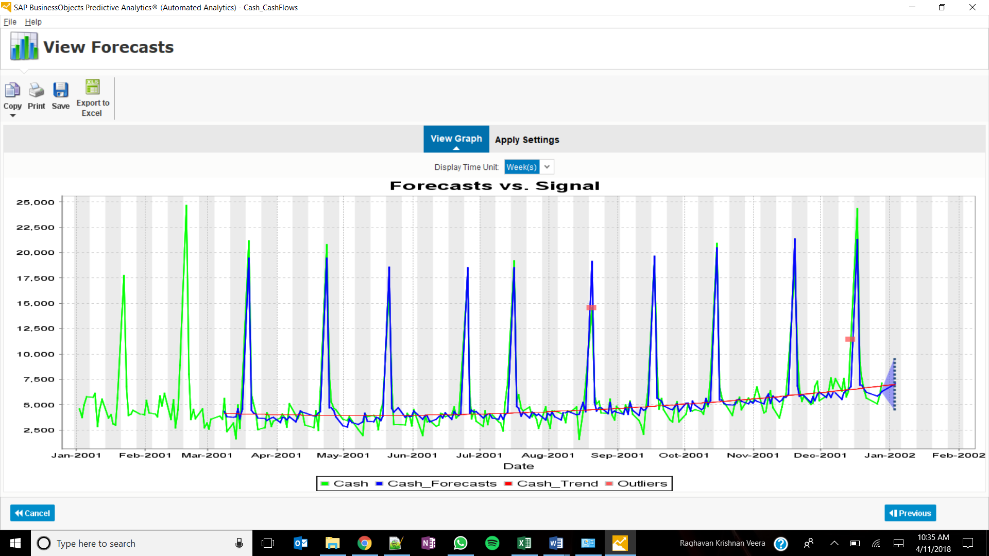

Model Output:

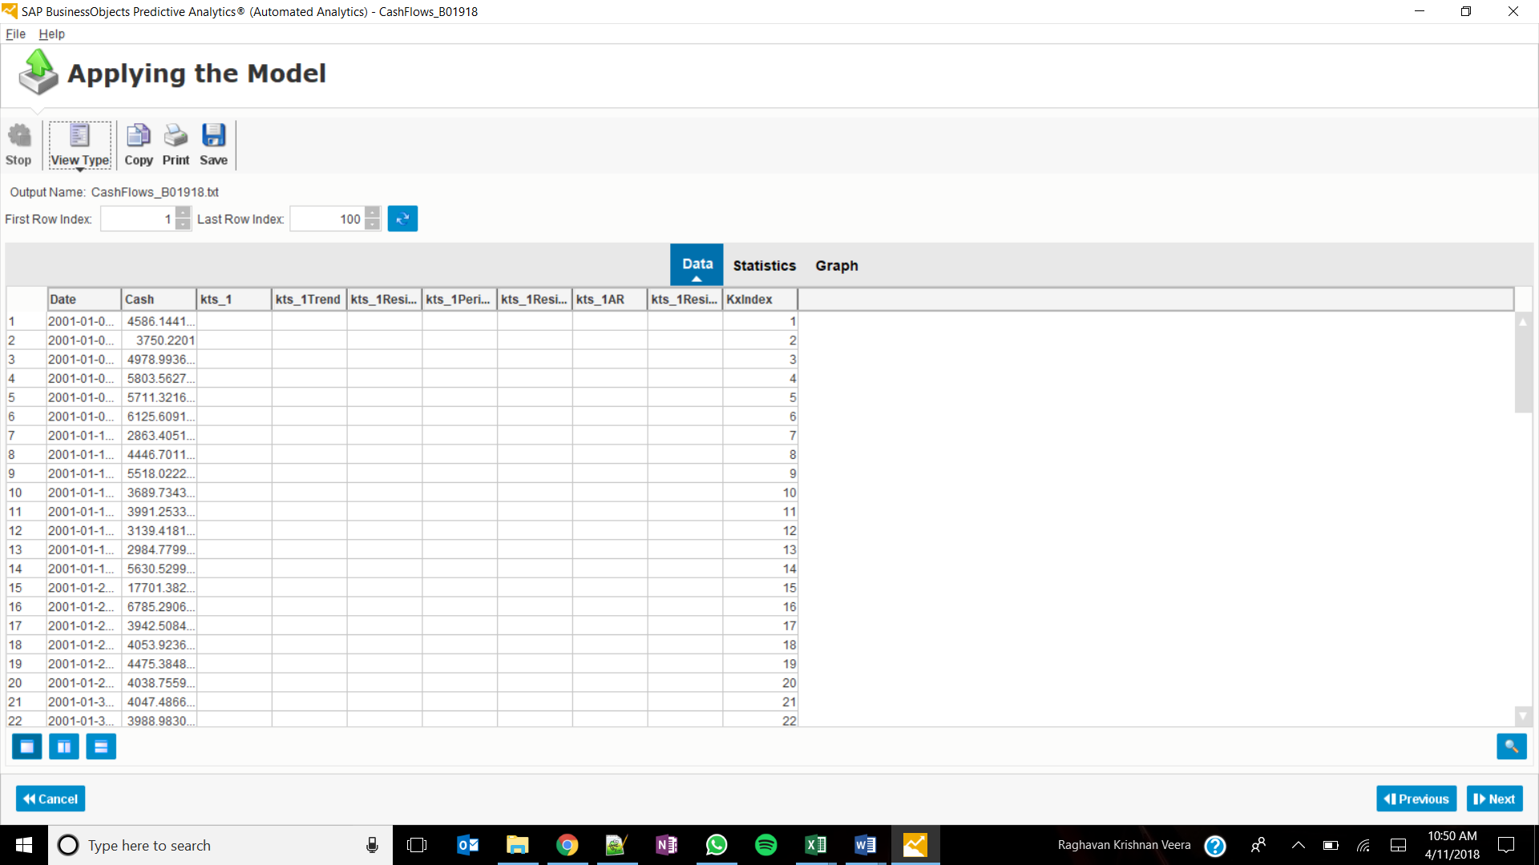

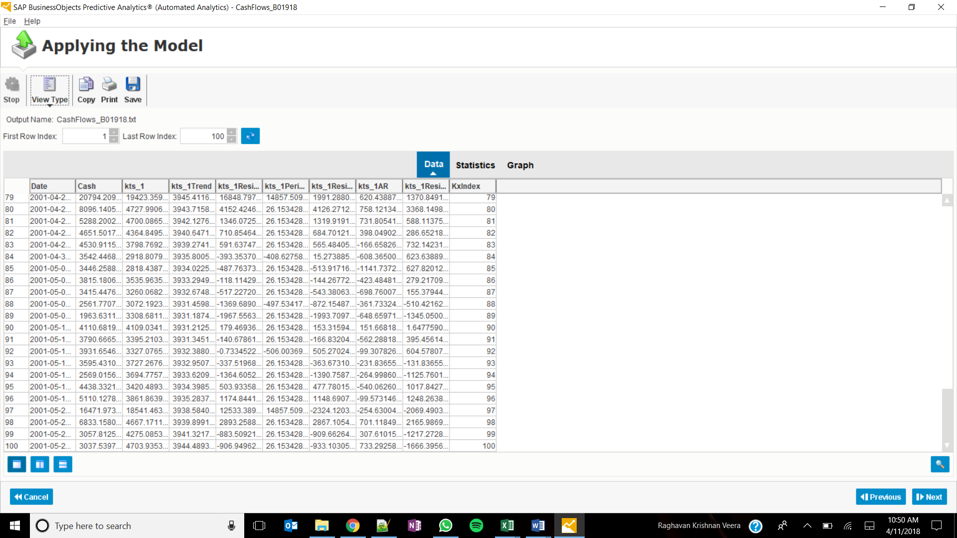

Support is the way to find that how many times a combination of products have been bought from the total transactions. For example, how many time A & B have been bought together.

Confidence - It indicates how often the rule has been found true given that the antecedent has been purchased.

SessionID

Minimum Support – 10%

Minumum Confidence – 50%

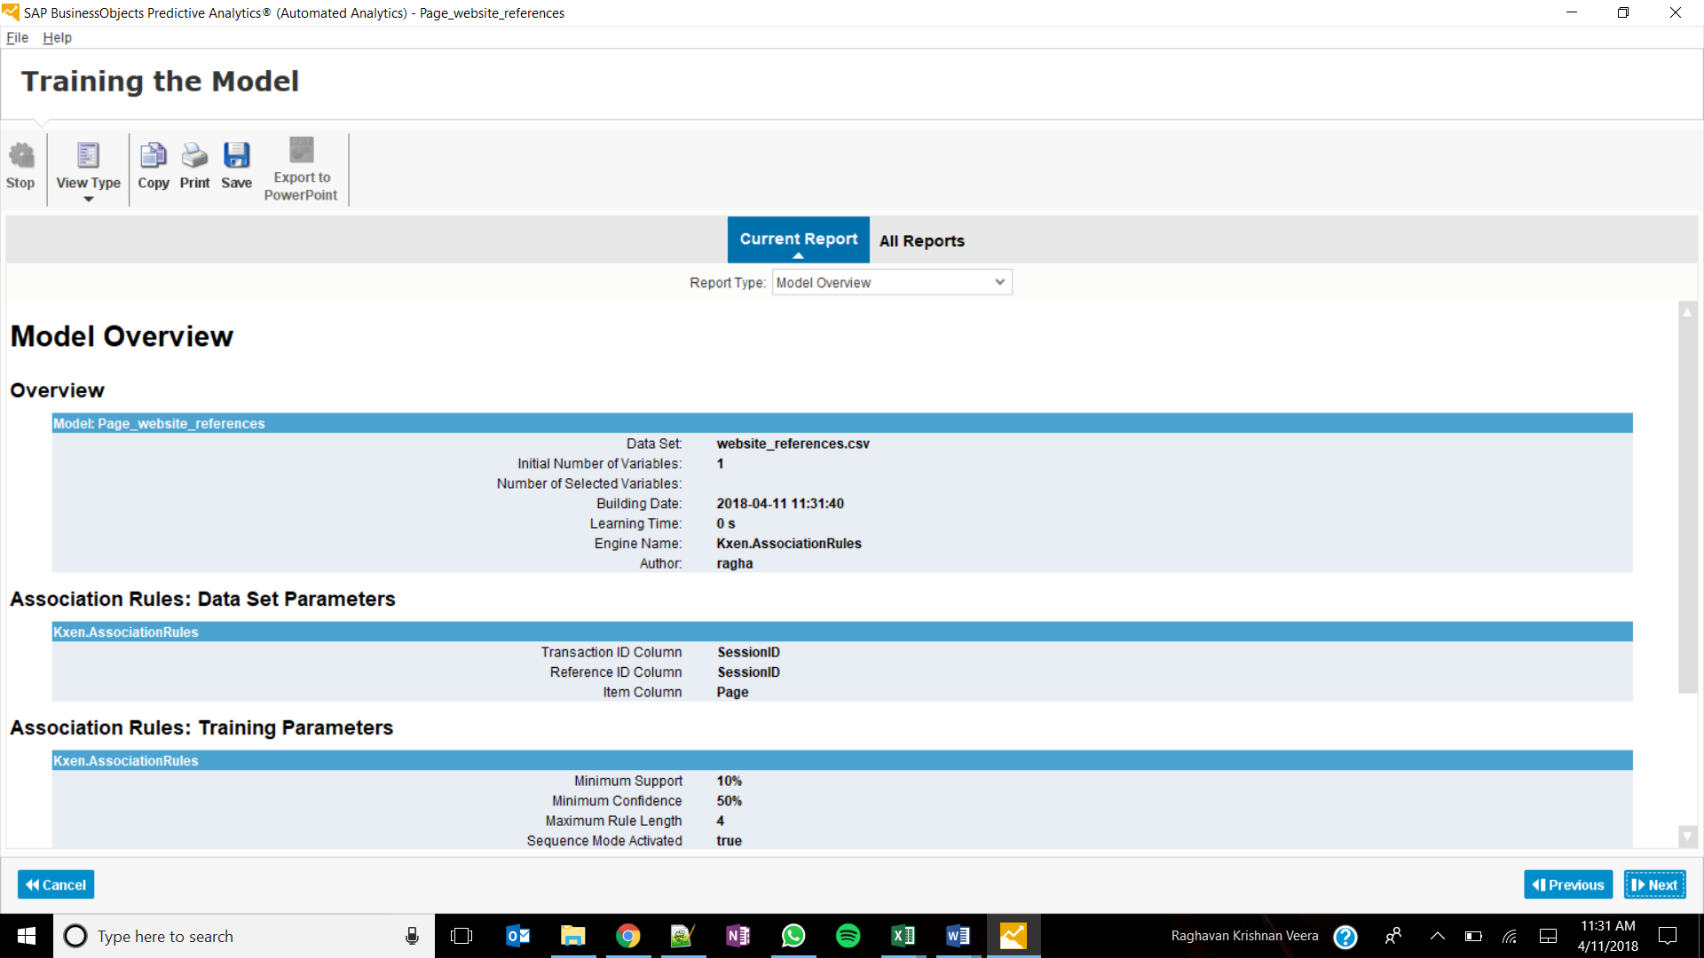

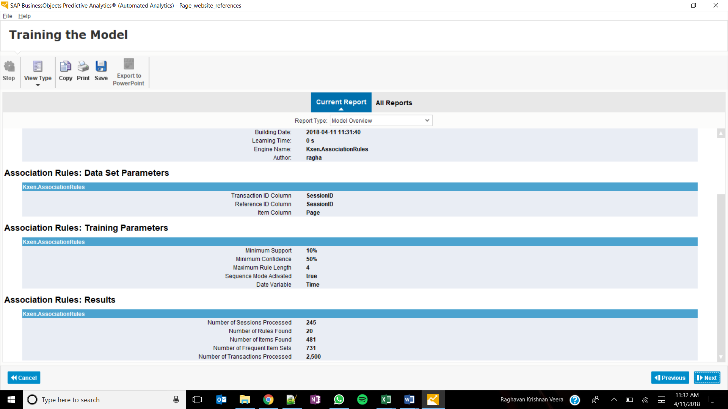

20 rules are found

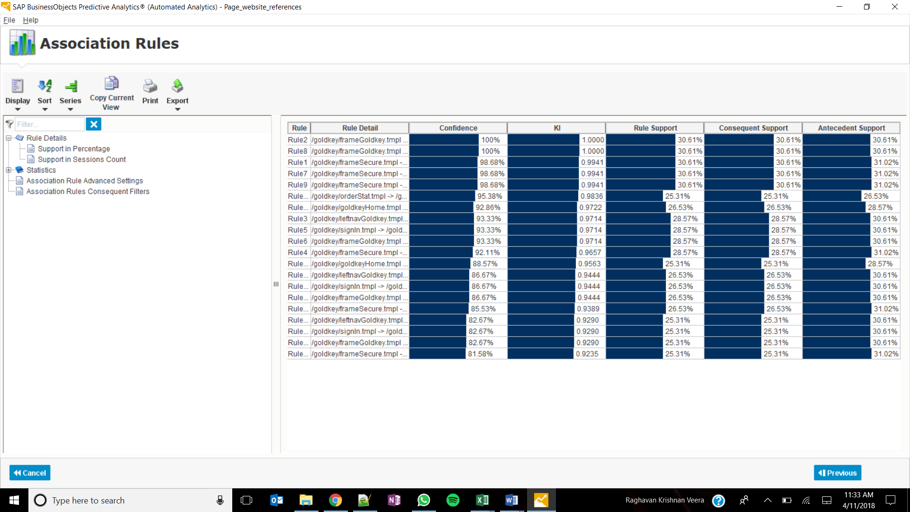

Support for the rules with 100% confidence is 30.61%

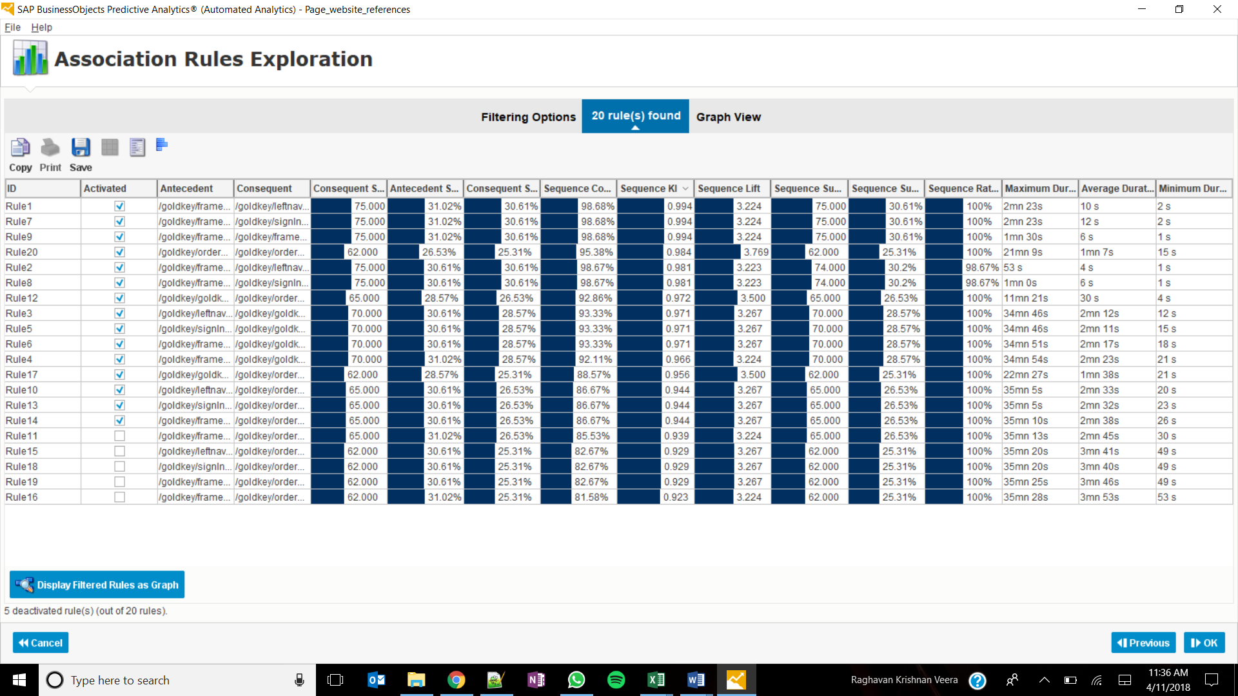

Sequence KI considers the order of the events in the rule whereas the KI doesn’t.

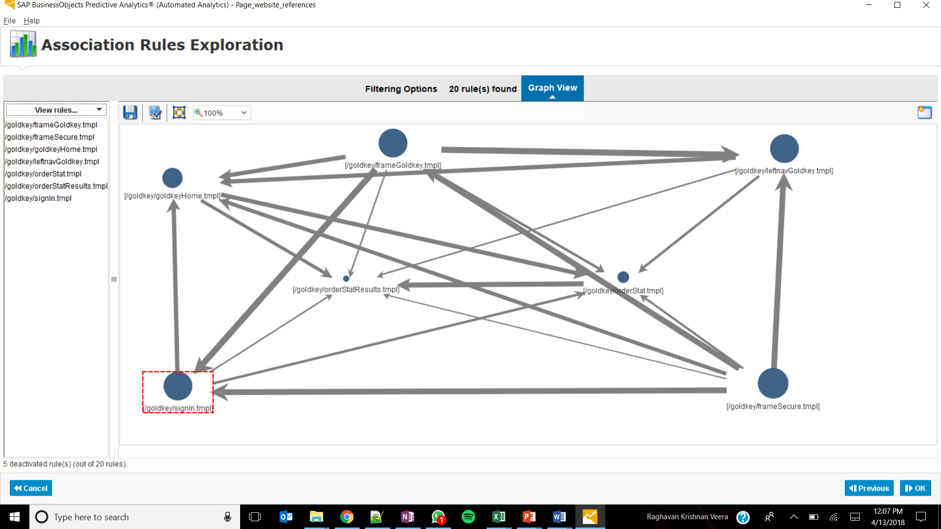

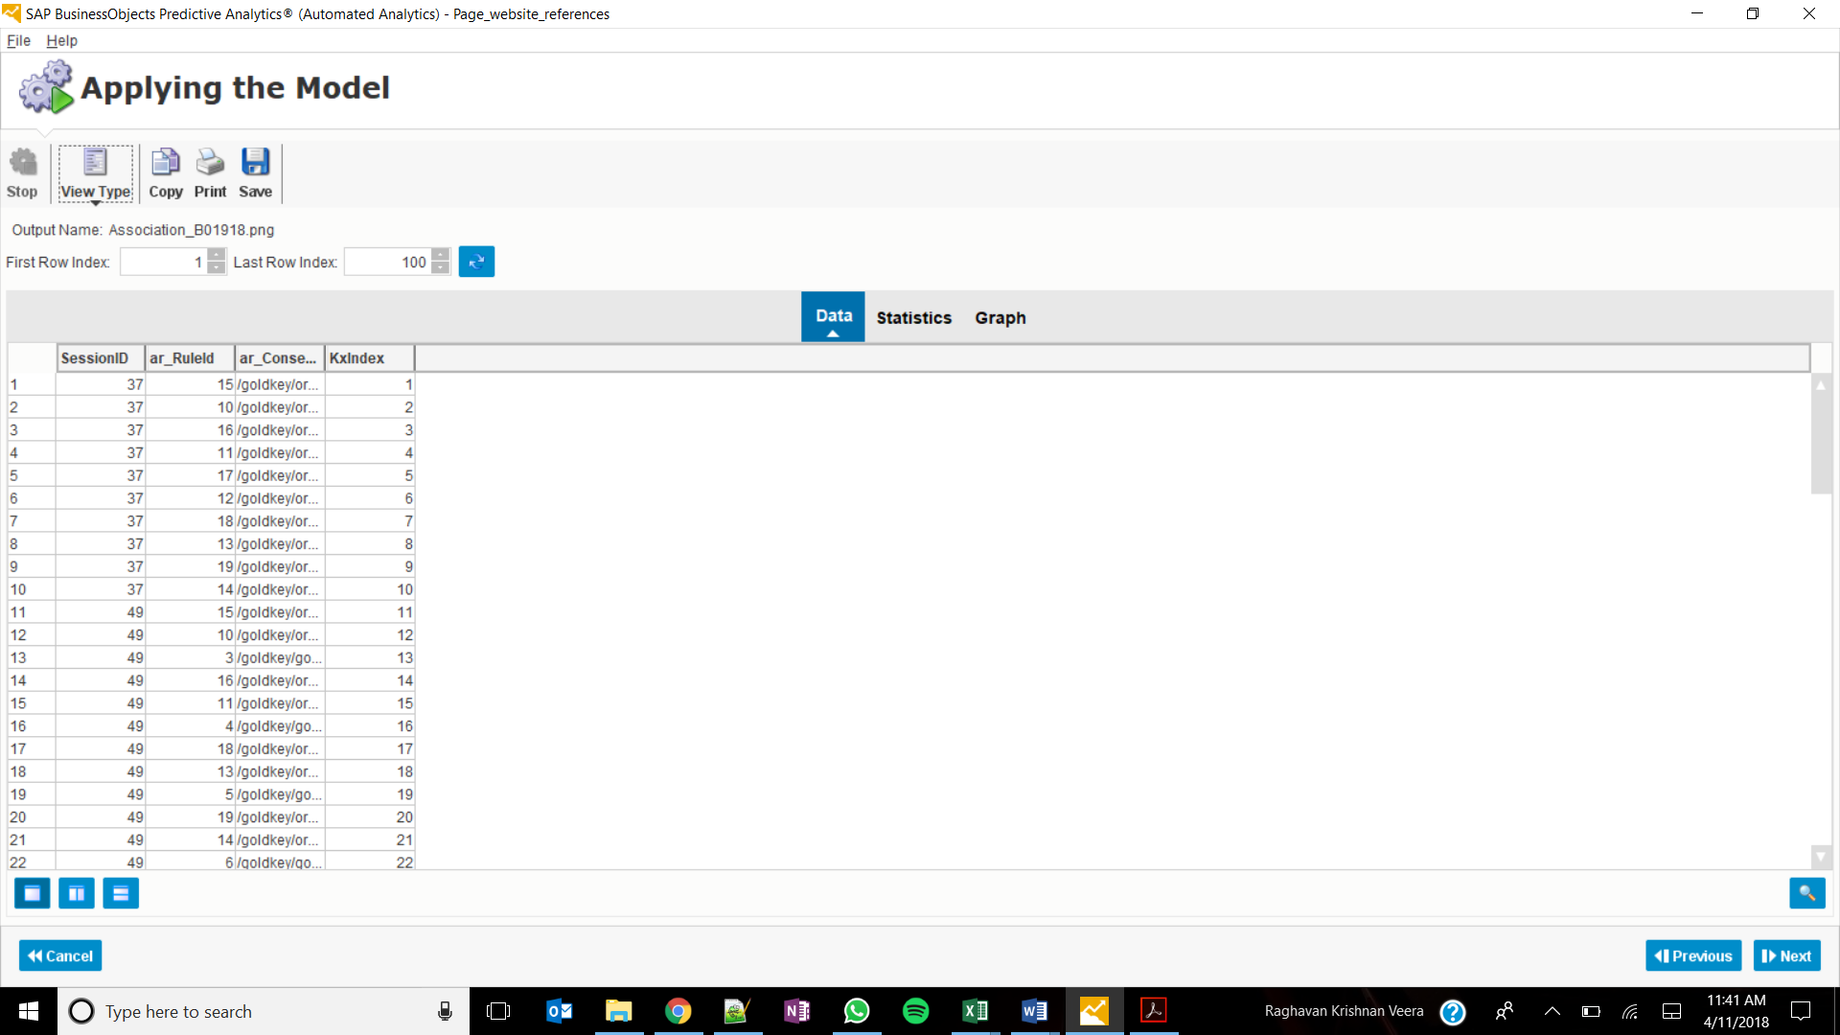

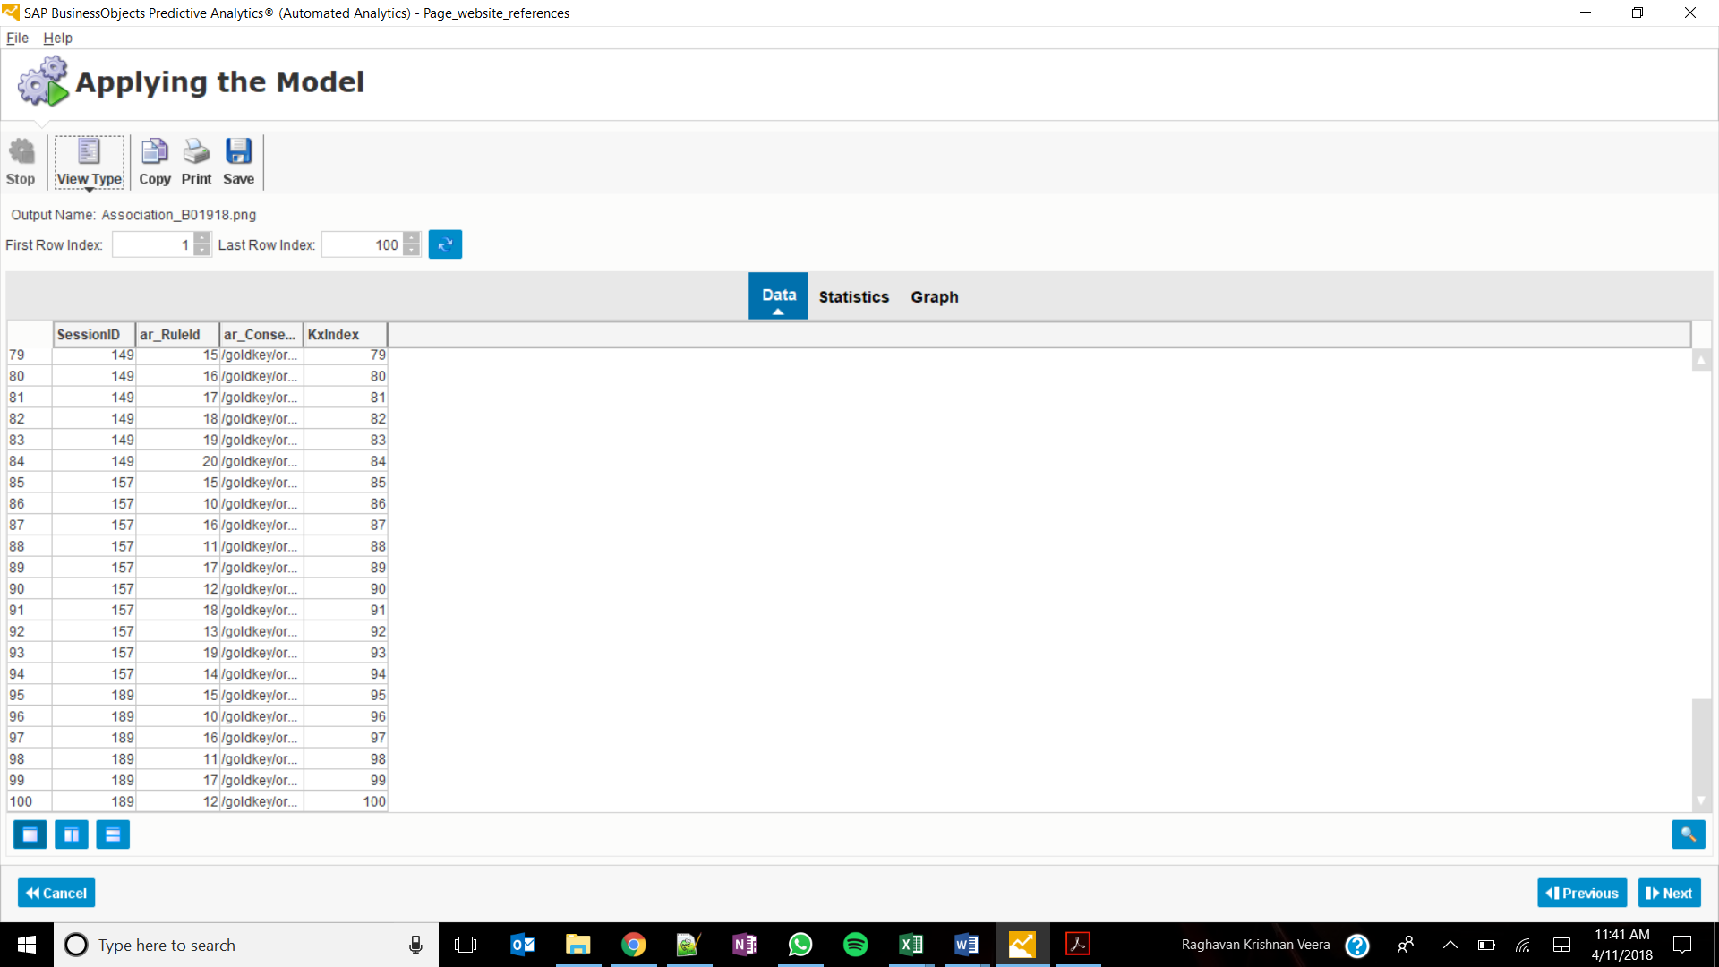

Predictive Power 0.7107

Predictive Confidence .9943

9 Clusters

Highest Class value with capital gain - Cluster 2

Gain 8682.24

Cluster 5 has the lowest value of class

Average 28.4754

Cluster 2 has the highest value of class

Average 44.6052

Category of marital status:

Married- AF-spouse-; Married- civ-spouse

Frequency % of cluster 1 24.48

What is the ‘% of 1’ value for cluster 1? 26.88

What category of marital status has highest influence on cluster 1? Married-civ-spouse

Cluster output:

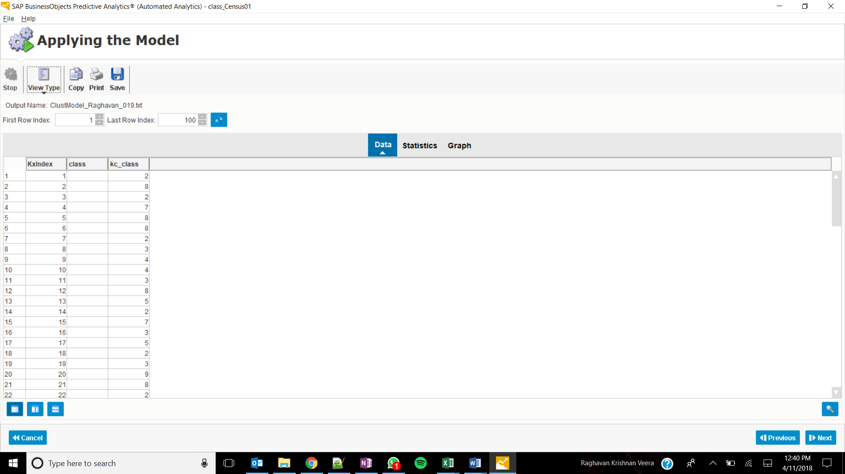

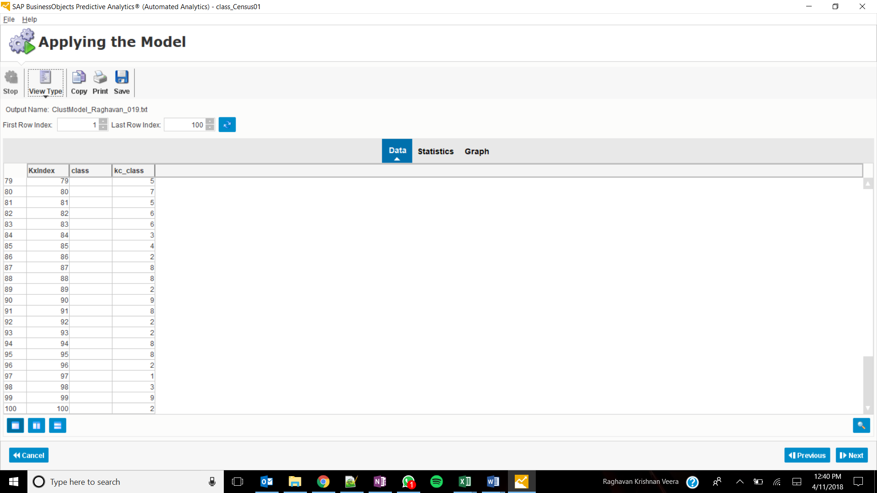

Classification:

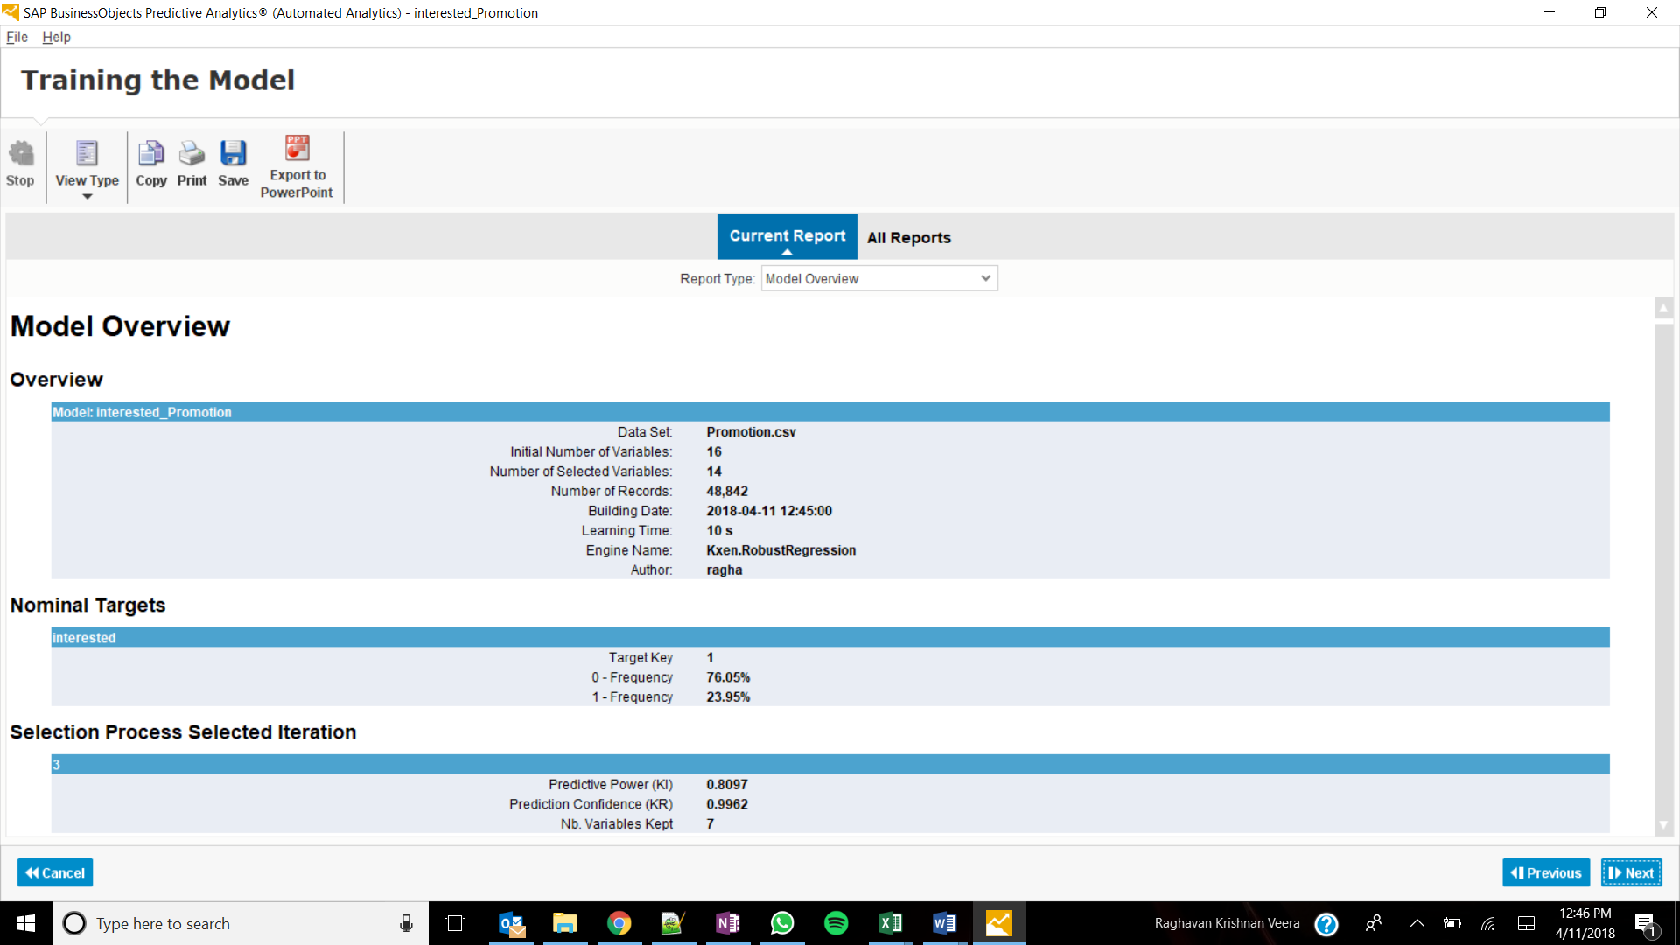

Predictive power: 0.8097

Predictive confidence: 0.9962

Definition: Predictive power is a measure of how effectively the model was able to assign customers to clusters based on the available variables.

Prediction confidence is a measure as to how well the model will generalize to a new dataset.

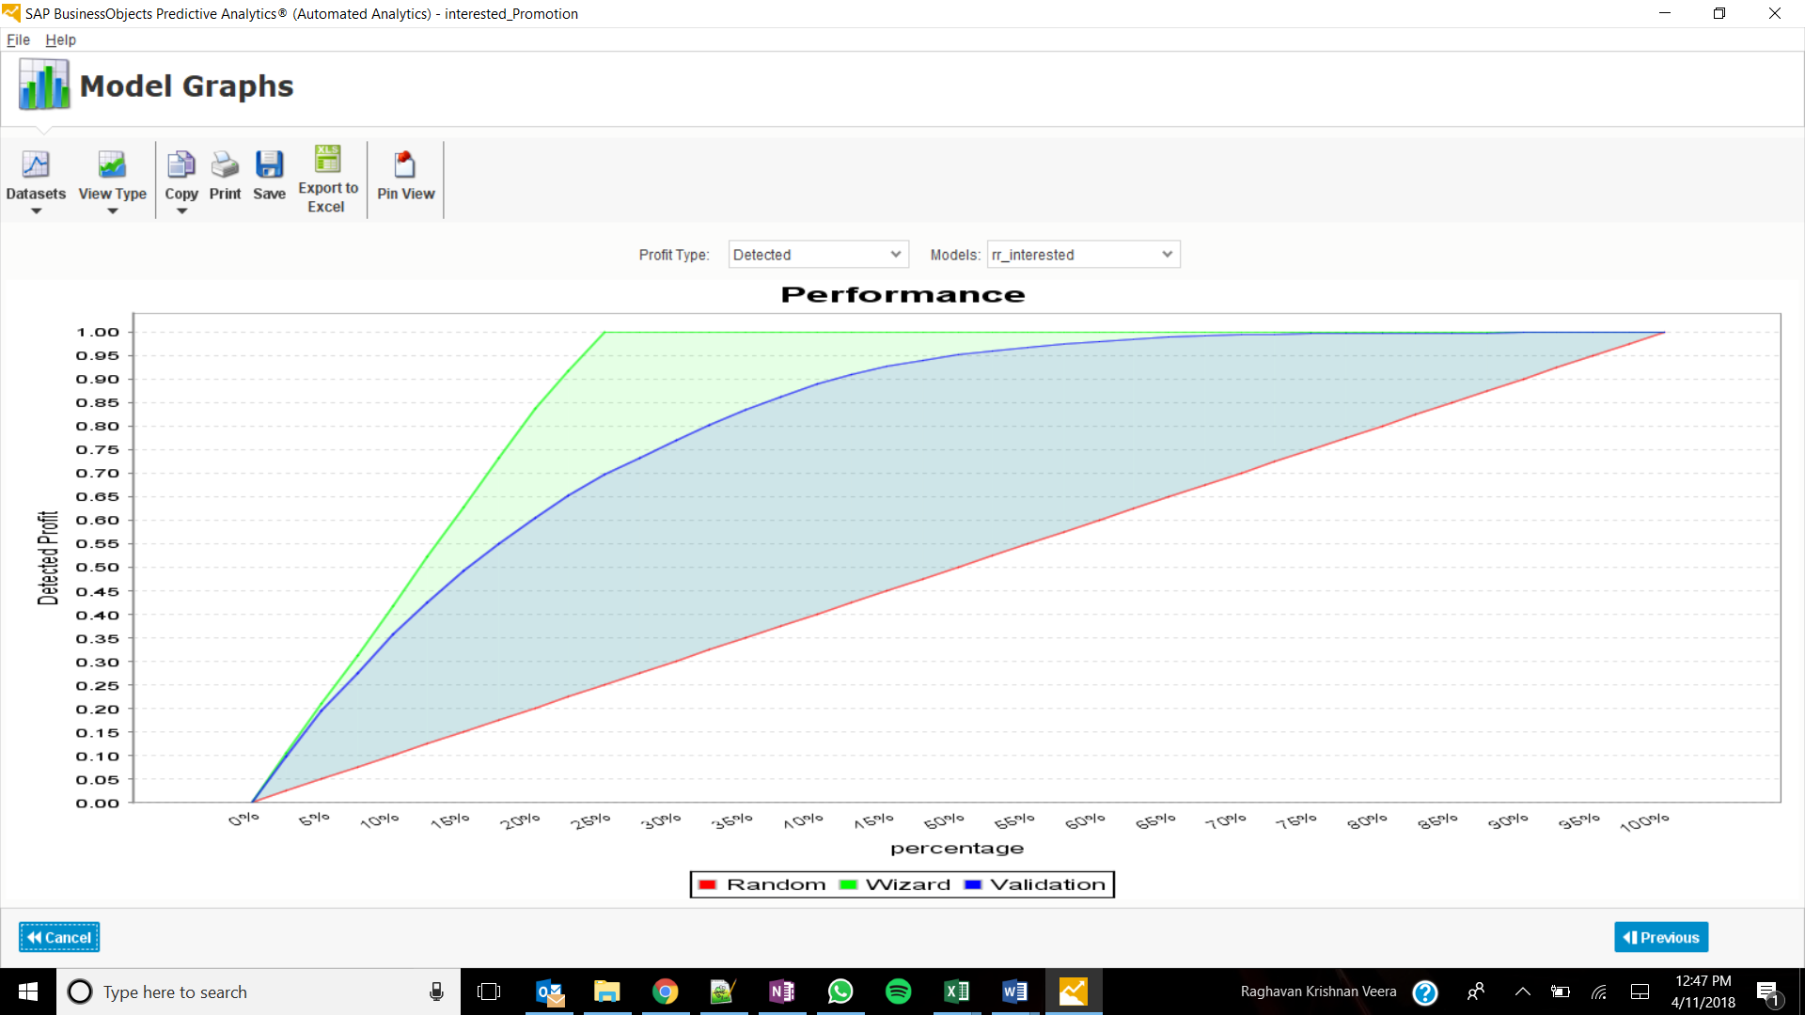

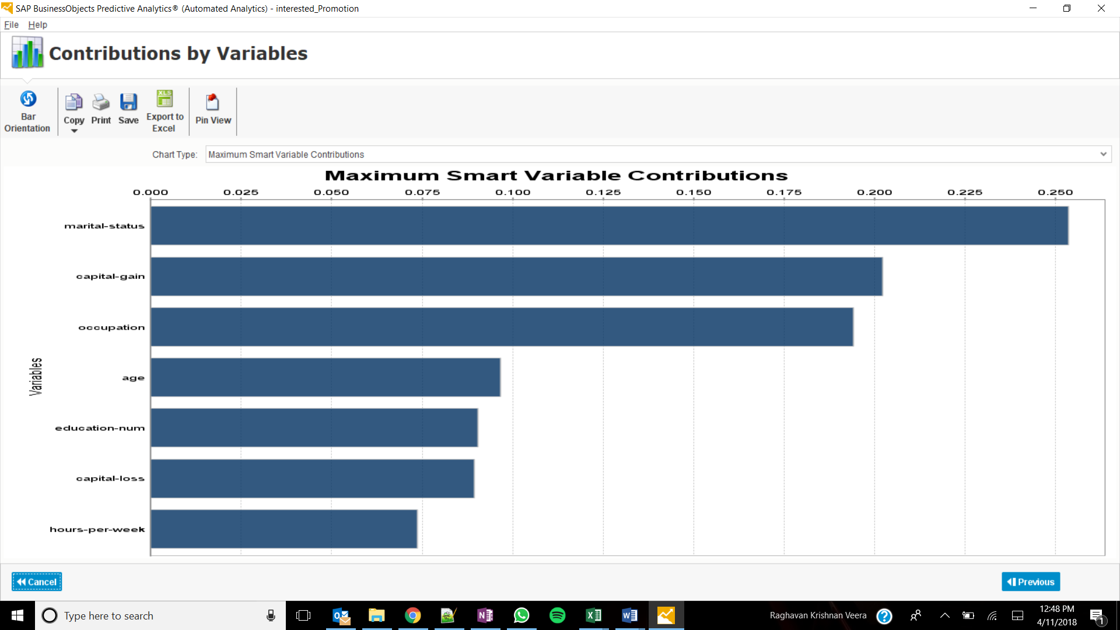

Marital-status

Capital-gain

Occupation

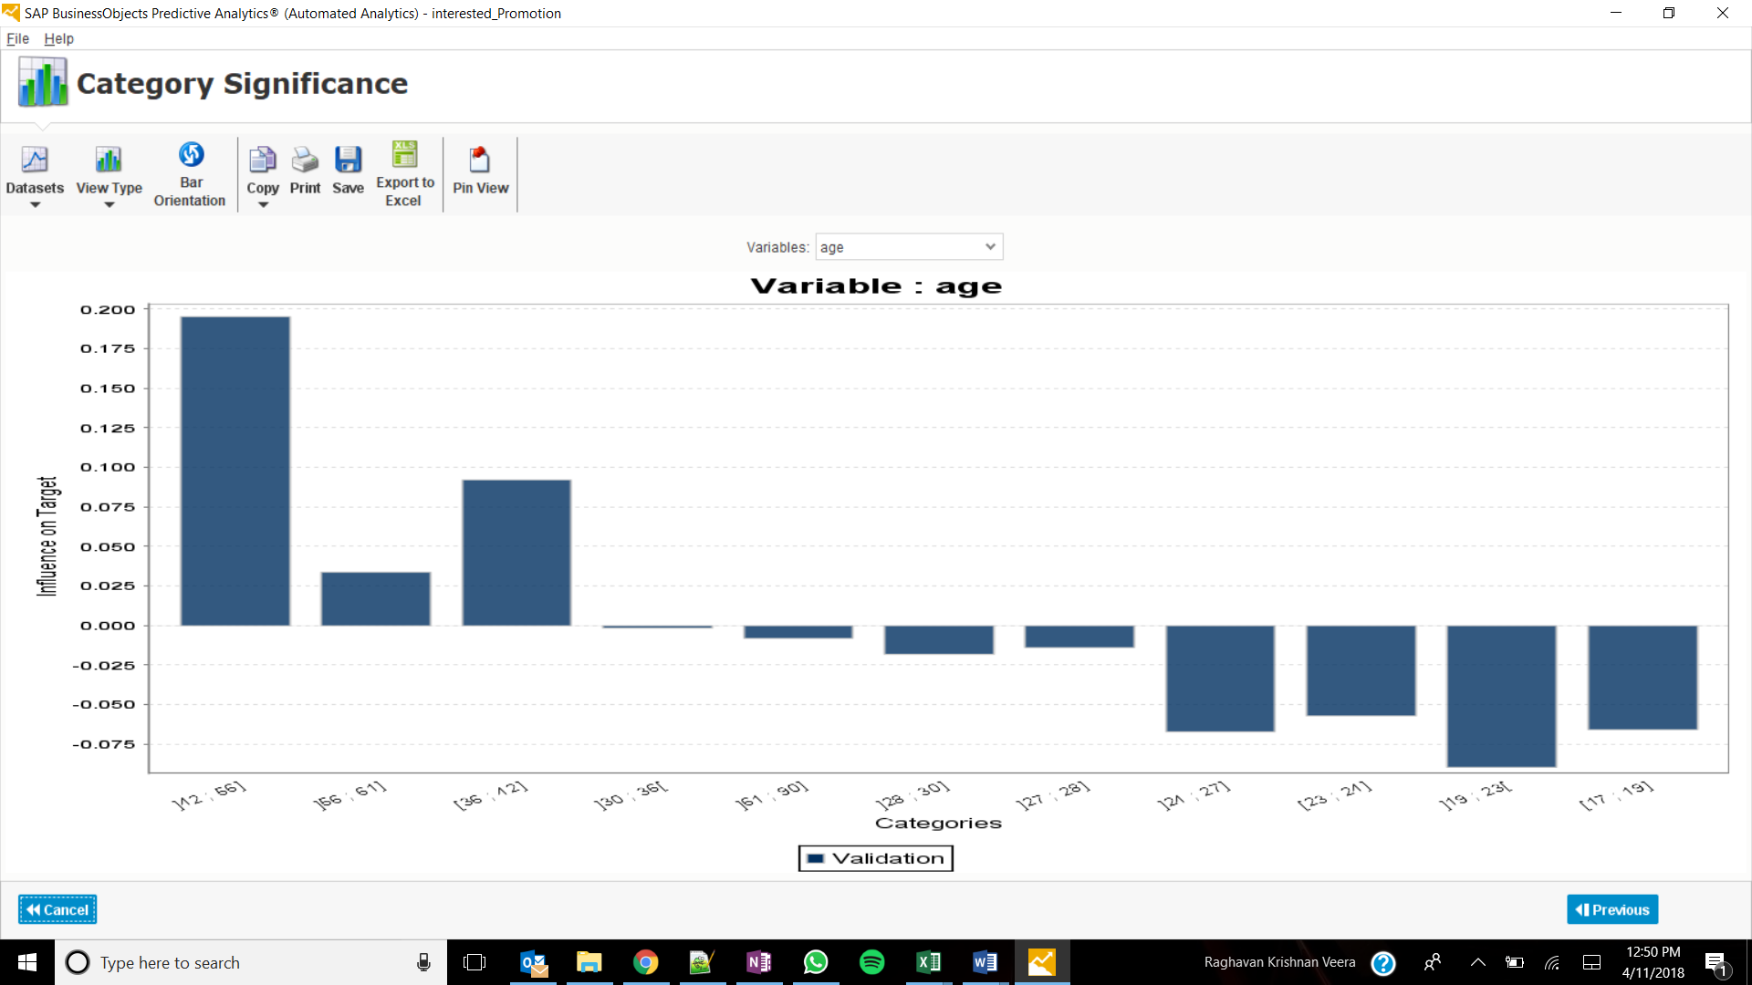

Group ]42-56]

Profit – 0.2

Frequency: 25.2%

Group ]19-23] has the least significance

Profit -0.09

Frequency 7%

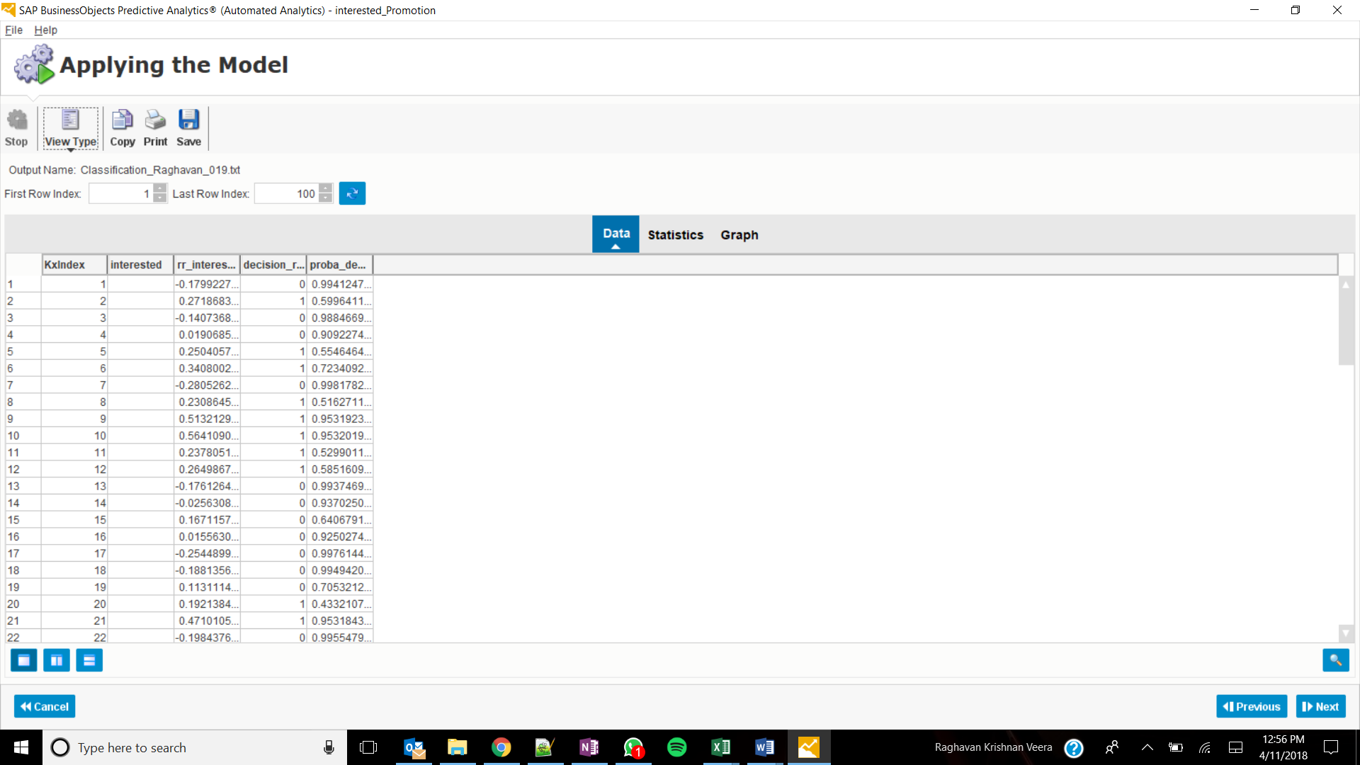

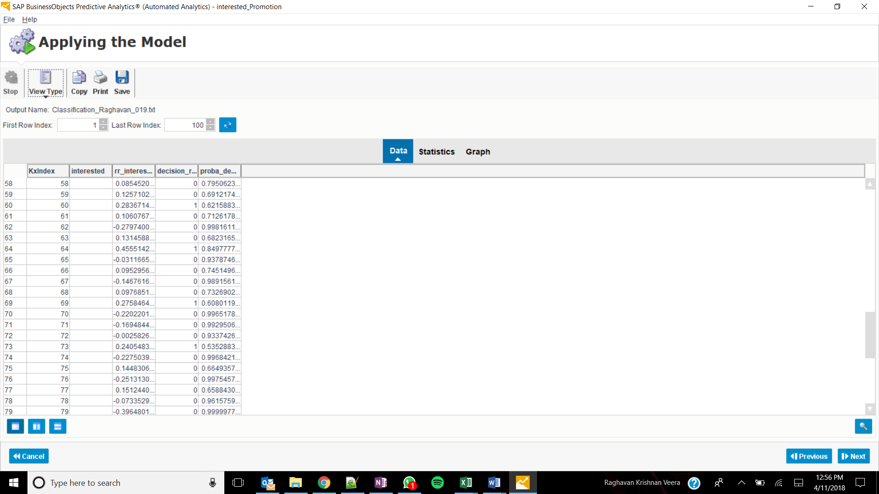

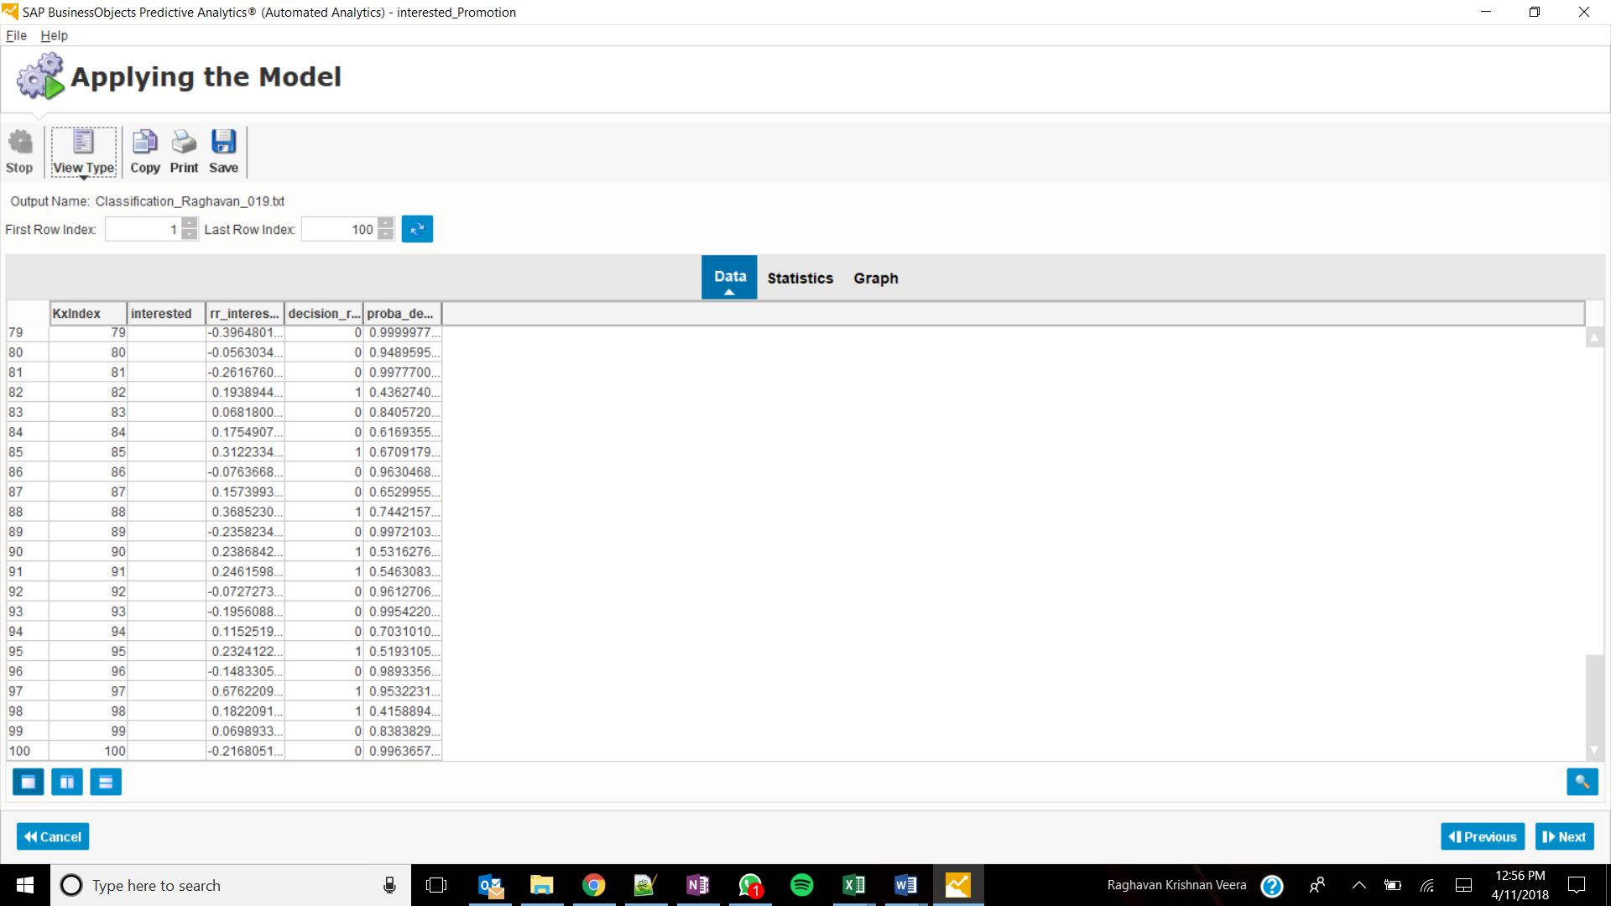

Decision_rr_interested